# Project Organisation

In the feasibility study and IT plan, we have already created a schedule, a Gantt chart, and a work breakdown structure (WSB). In this section, the type of organisational structure used is the organic organisation structure.

An organic organisation structure is flexible, adaptable, decentralised, suitable for unpredictable changes in the environment, and an informal approach to decision-making. The structure allows for a more flexible and dynamic decision-making process that often empowers project members and encourages collaboration across all departments and levels, in this case, task (AIHR, n.d.).

The reasons why this was chosen for our project organization are:

* Flexibility
* Easy communication
* Few and broadly defined rules and regulations
* Active participation between group members during the decision-making and problem-solving process.

Organic project organisation structure works well with the Agile framework, as both are used in unpredictable development environments, where constant changes happen, flat structures and less supervision (Devi, 2016).

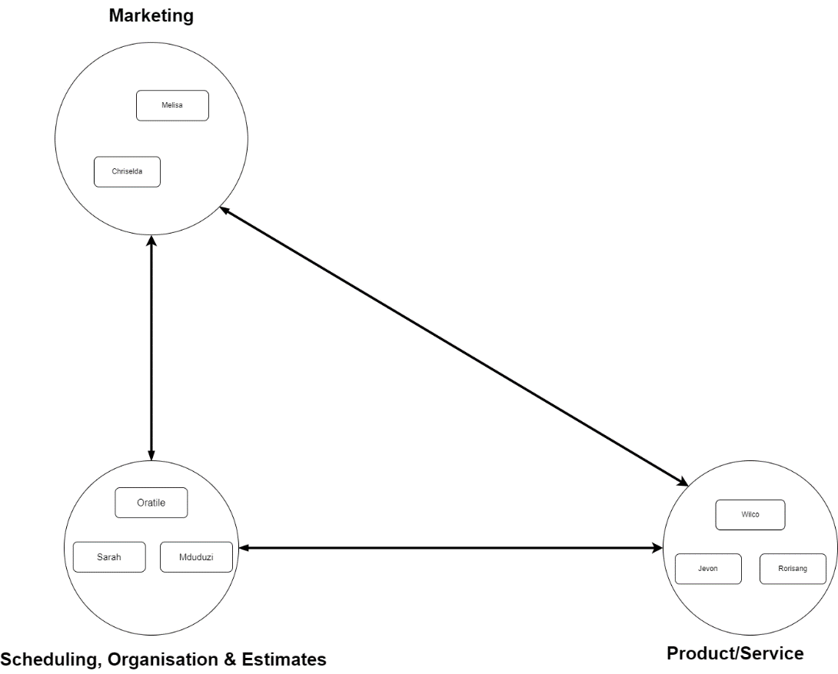

[Note get group input on organisation structure]

# References

AIHR. n.d. *Organic Organizational Structure*. <https://www.aihr.com/hr-glossary/organic-organizational-structure/> Date of access: 15 May 2024.

Bhasin, H. 2023. *Organic Organisation - Definition and Characteristics*. <https://www.marketing91.com/organic-organization/> Date of access: 17 May 2024.

Devi, V. 2016. *An Organization Development (OD) Approach to Agile Adoption*. <https://www.infoq.com/articles/od-approach-agile/> Date of access: 17 May 2024.